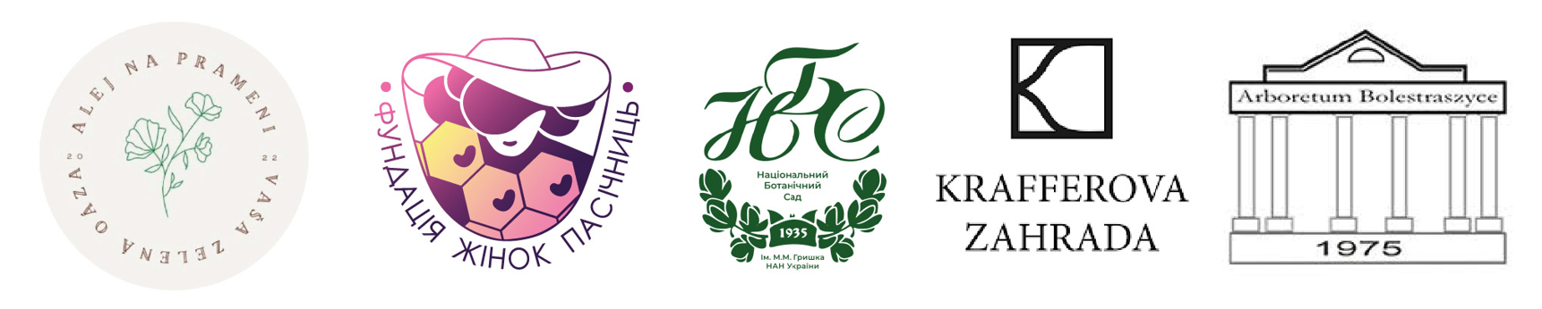

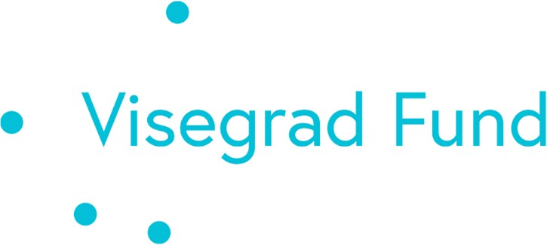

the project Health Tourism: Garden and Bee Therapy for Ukrainian Women and Children's Mental Health
supported by Grant from International Visegrad Fund
V4countries of European Union,
Implementation period 20/06/2025–30/04/2026
Project ID 22510239

Final online International Conference on the results of the Project implementation and presentation of the Healthy Tourism Model* (Event—Public), Nitra, SK
📌 *Conference Title*
International Final Conference on Healthy Tourism: Integration, Innovation, Inspiration
📝 *Short Announcement*
On February 28, 2026, the city of Nitra (Slovakia) will host the International Online Conference dedicated to the results of the project and the presentation of the Healthy Tourism Model.
Participants from various countries and organizations will discuss innovative approaches to combining tourism, mental health, and ecological sustainability. The program will feature partner presentations, guest speakers, and the official launch of the Guide to Healthy Tourism, designed as a practical tool for advancing green and wellness tourism across Europe.
📑 *Preliminary Conference Program* (10:00 – 14:00 CET)
10:00 – 10:20 | _*Opening and Welcome*_
• Greetings from organizers and partners
• Overview of project results
10:20 – 11:00 | _*Main Section: Healthy Tourism Model*_
• Presentation of the concept and the Guide to Healthy Tourism
• Integration of mental health into green tourism practices
• Experiences from international partners
11:00 – 12:00 | _*Thematic Blocks*_
• Apitherapy and Beekeeping Products – Impact on mental health and quality of life
• Aromatic Garden and Medicinal Plants – Selection of plants for therapeutic spaces
• Psychotherapeutic Practices in Tourism – Common methods for supporting mental health
• Social Issues in Partner Countries and the EU – Analytical overview and discussion
12:00 – 12:40 | _*Special Section: Healthy Nutrition*_
• Nutrition as a key component of wellness tourism
• Presentation of beekeeping products and their benefits for mental health
12:40 – 13:20 | _*Panel Discussion*_
• Perspectives on the future of Healthy Tourism in Europe
• Q&A session with participants
13:20 – 14:00 | _*Closing Session*_
• Summary of conference outcomes
• Announcement of the final report and next step
✅Registration for the conference here: https://forms.gle/7aqsSoukoBUjKLm88**
Zoom (https://us06web.zoom.us/j/86706585180?pwd=FPiN2pAvj7ybhgYWrGAC23DKaMXKoj.1)
28/02. 2026 10:00 AM Nitra
ID 867 0658 5180
Code 779199

